**GIT and GITHUB 2**

**1)Install git.**

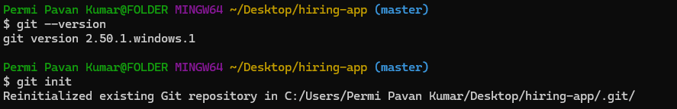

**2)Create a repo in github with README.md and .ignore file.**

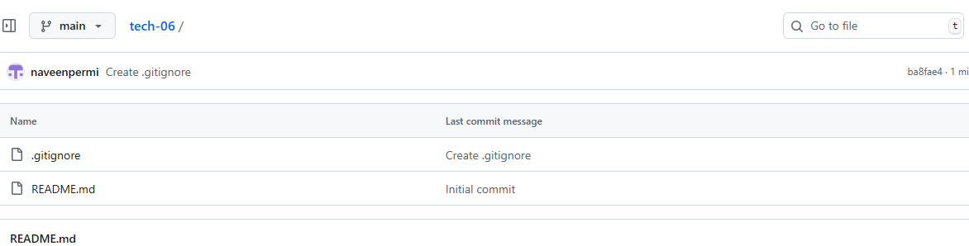

**3)Clone the created repo to local.**

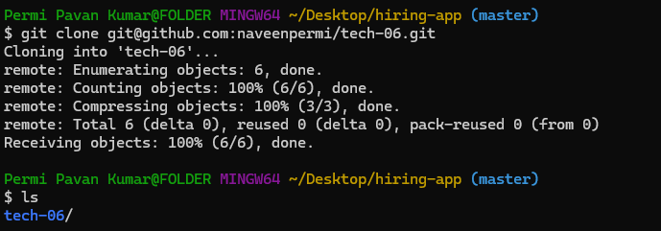

**4)Create two files in the local repo.**

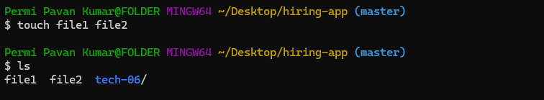

**5)Commit two files and push to the central Repository.**

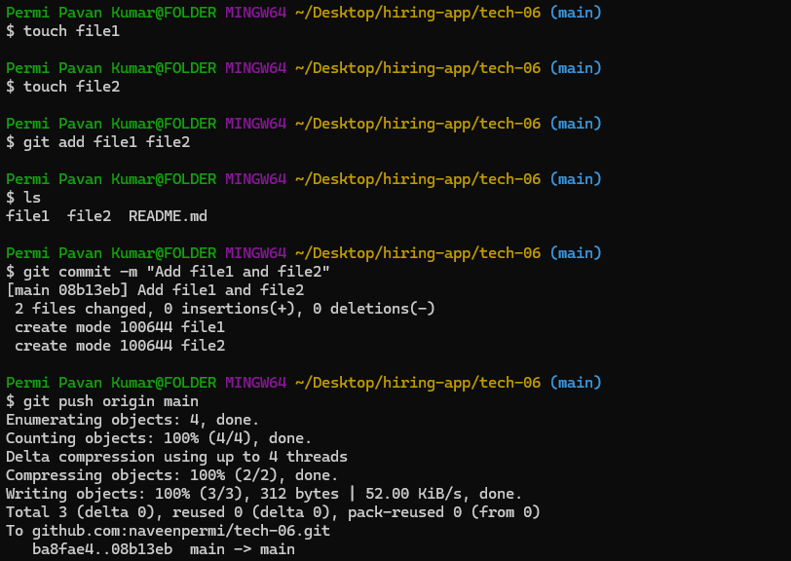

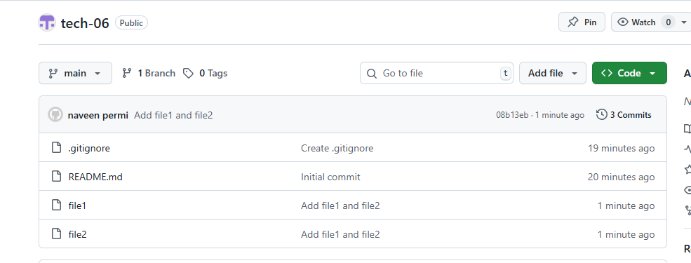

**6)Create a branch in local and create a sample file and push to central.**

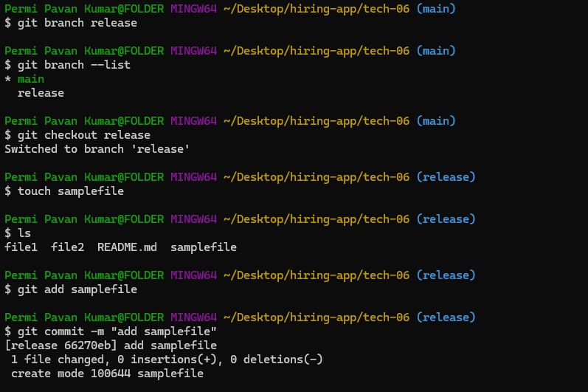

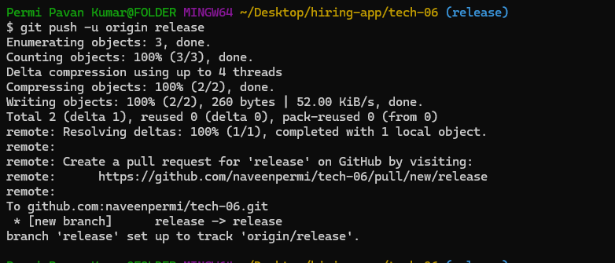

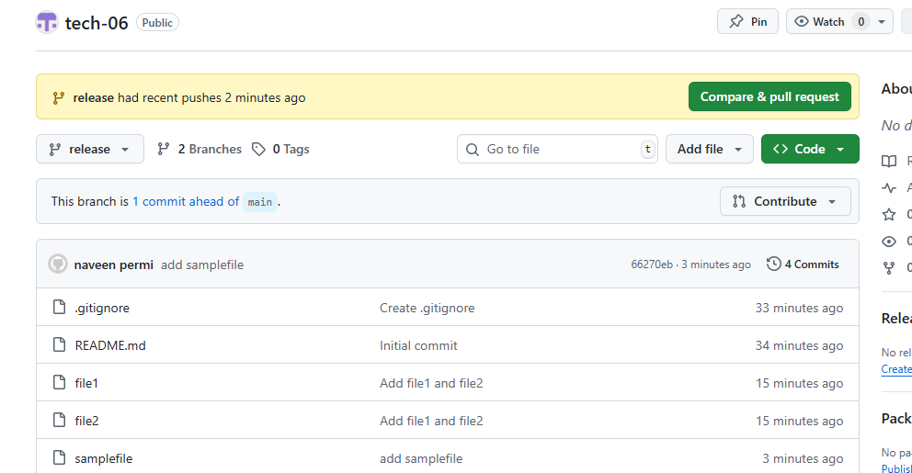

**7)Create a branch in github and clone that to local.**

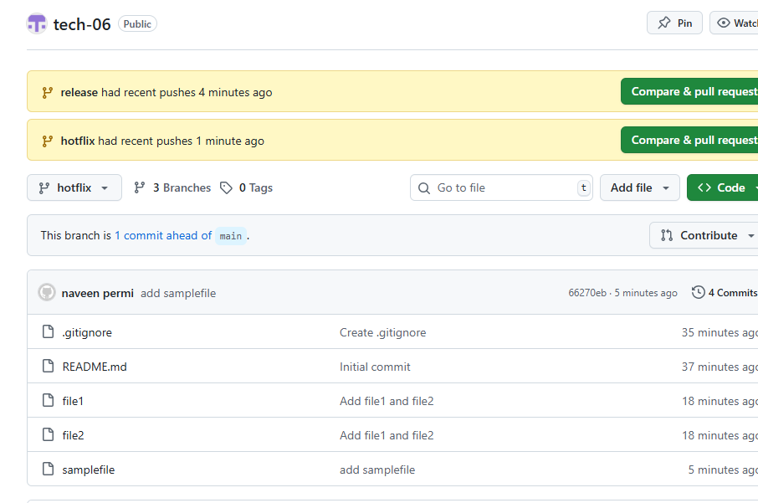

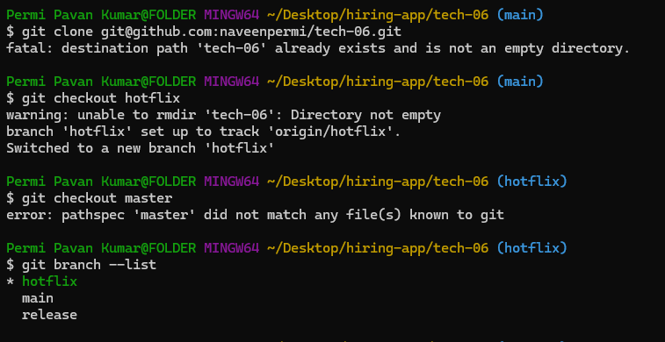

**8)Merge the created branch with master in git local.**

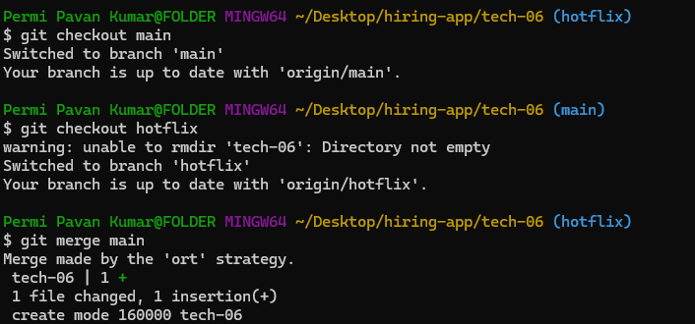

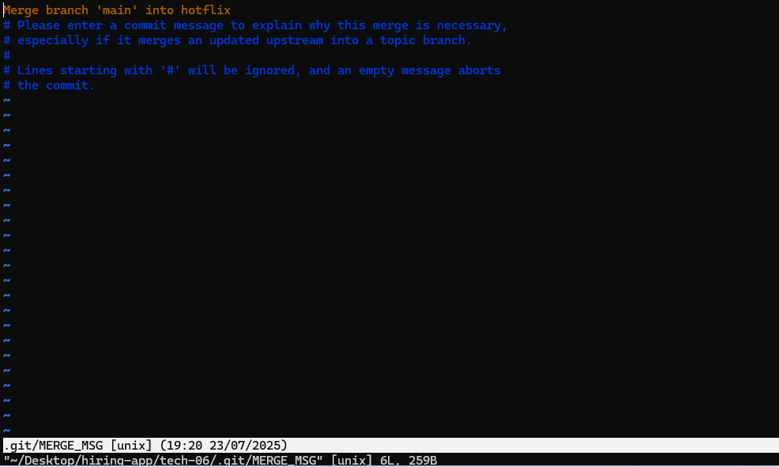

**9)Merge the created branch with master in github by sending a pull request.**

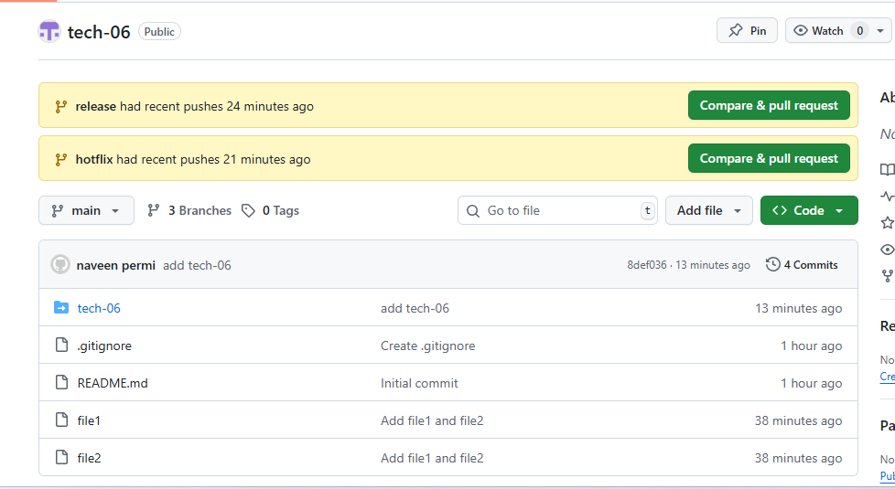

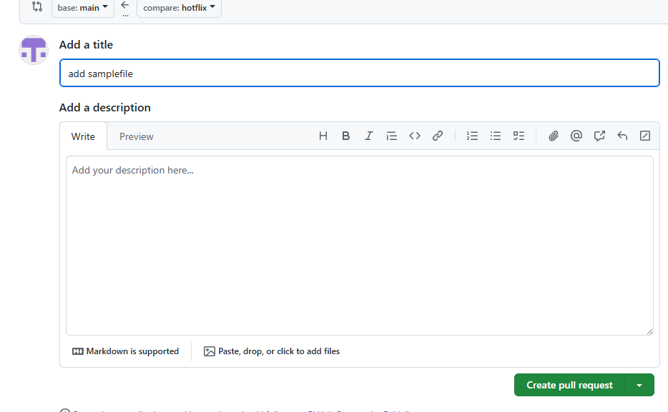

**10)create a file in local and send that to the branch in github.**





**11)clone only a branch from github to local.**



**12)create a file with all passwords and make that untrackable with git.**

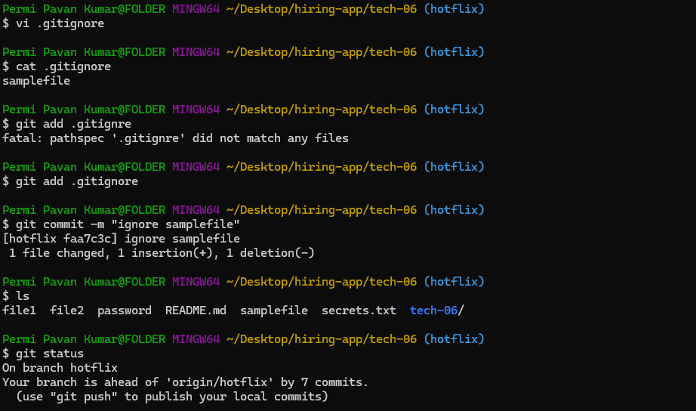

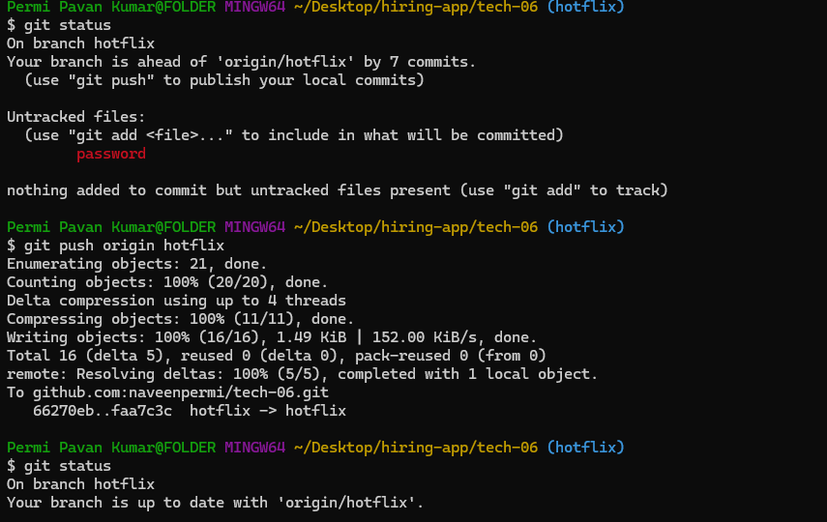

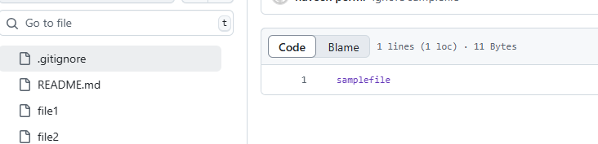

**13)make a commit and make that commit reset without saving changes.**

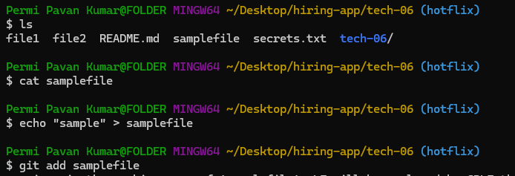

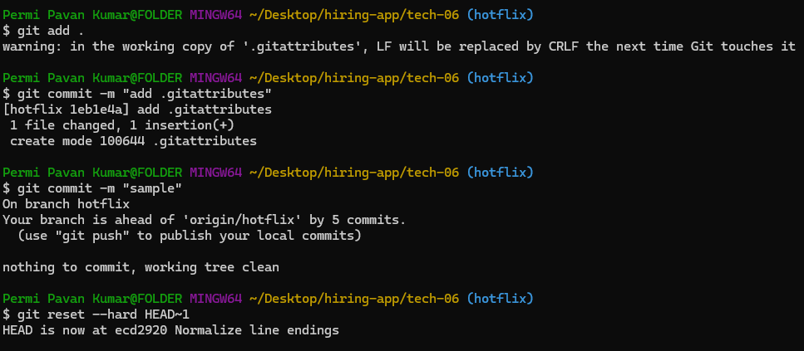

**14)Revert a commited commit to the older version.**

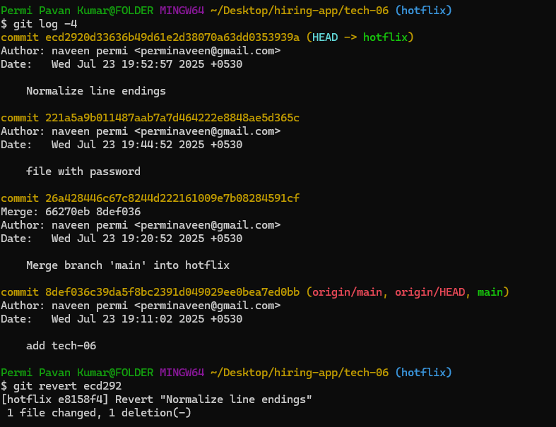

**15)push a file to stash without saving the changes and work on another file.**

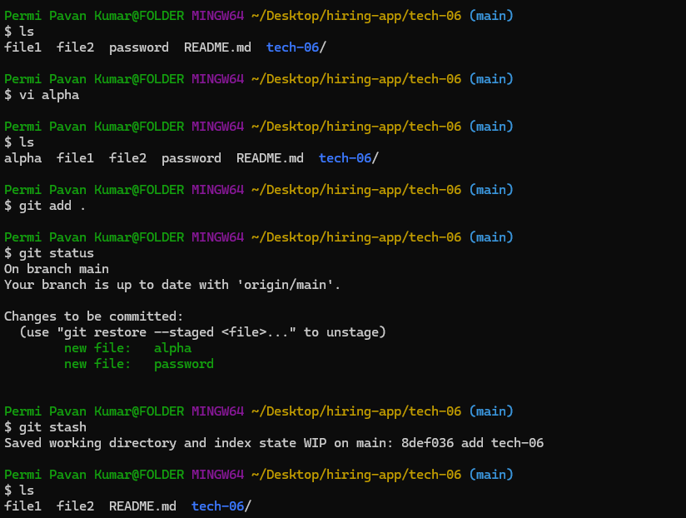

**16)undo the stash file and start working on that again.**

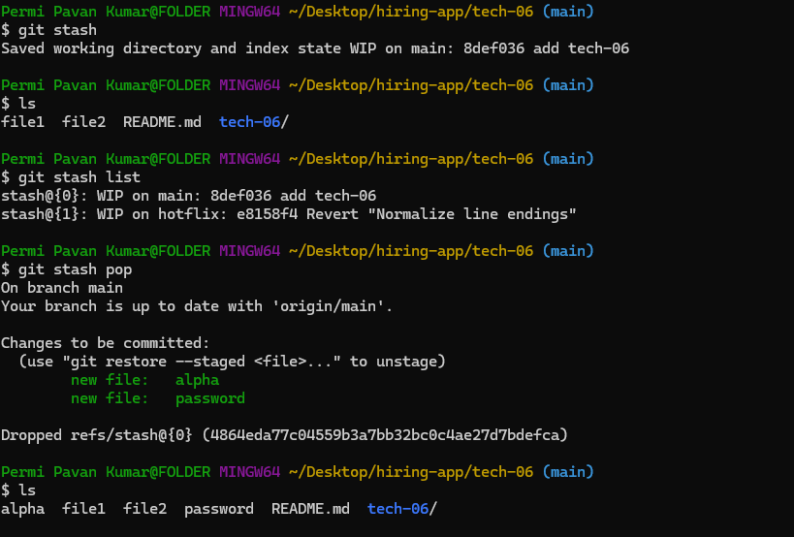

**17)generate a ssh-keygen and configure it into github.**

ssh-keygen

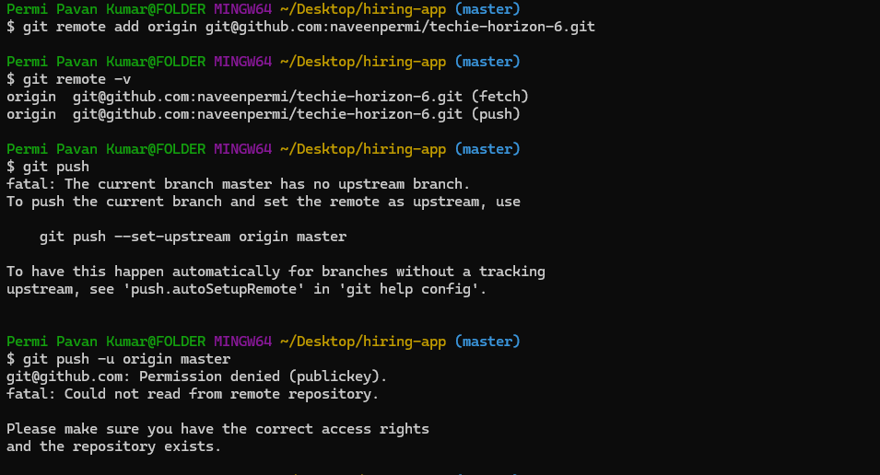

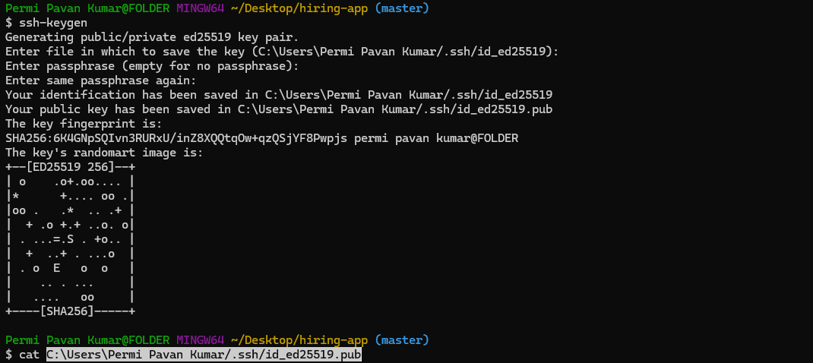

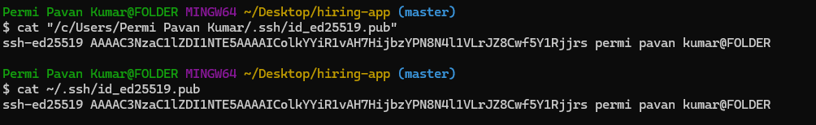

Go to settings in github then click SSH and GPG key to add ssh key.

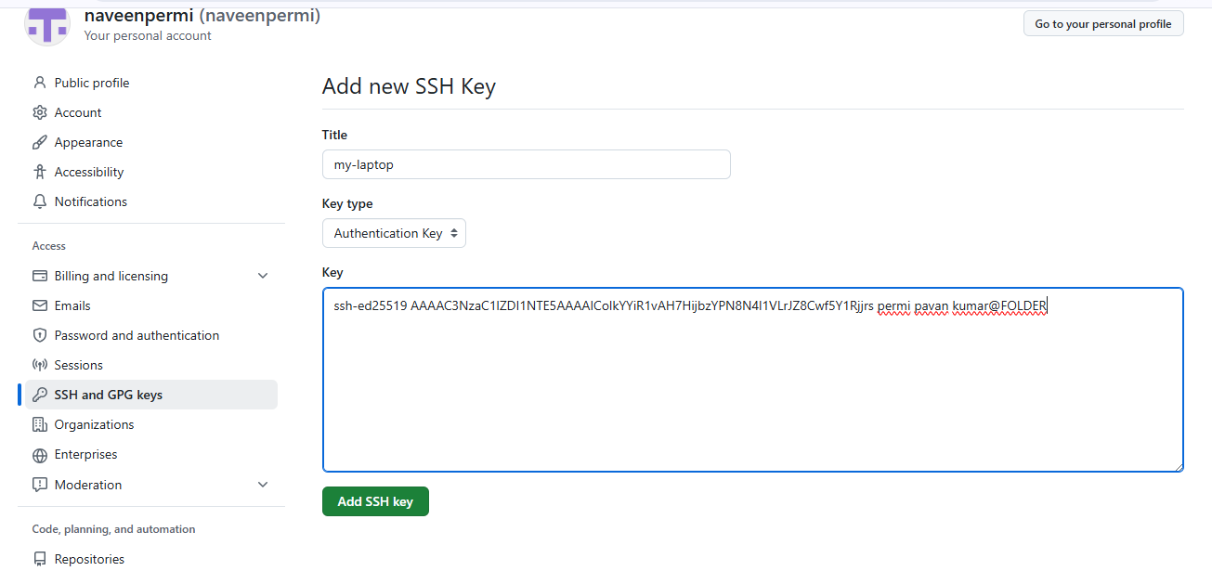

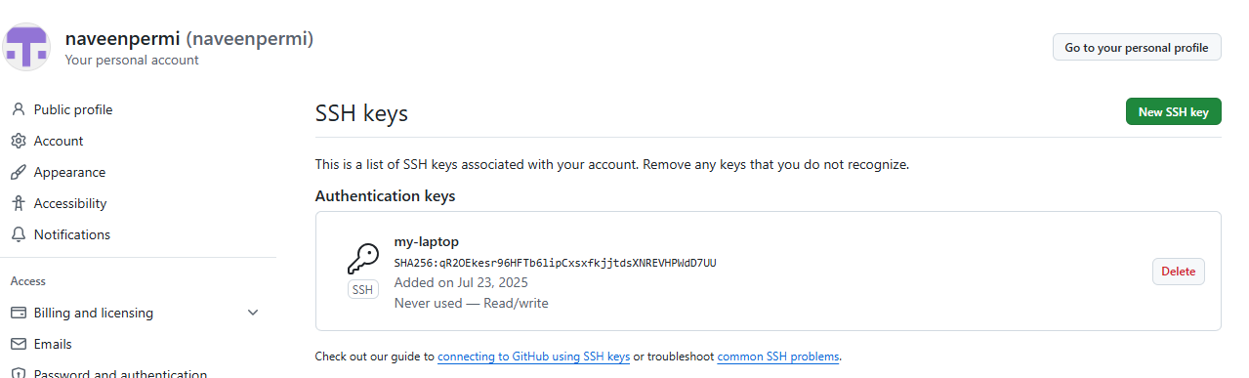

**18)configure webhooks to github.**

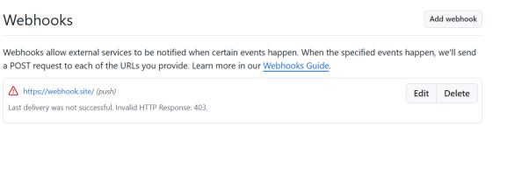

**19)basic understanding of the .git file.**

A Git repository is the . git/ folder inside a project. This repository tracks all changes made to files in your project, building a history over time

**20)Check all the logs of git.**

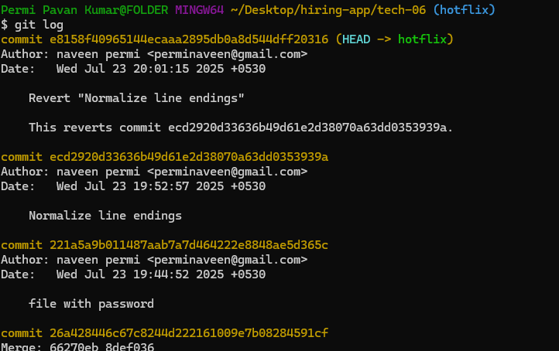

**21)Rename the commit message.**

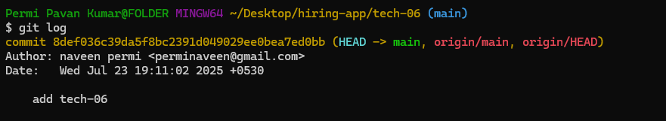

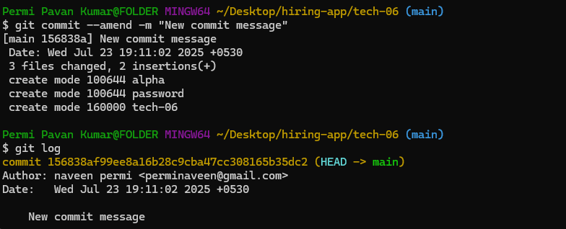

**22)Merge multiple commits into single commit.**

